Buckyball Sphere – Curved Folds:

http://sketchup.google.com/3dwarehouse/details?mid=7adc13e38221d66d6554b7d01658d0a6&ct=mdsa

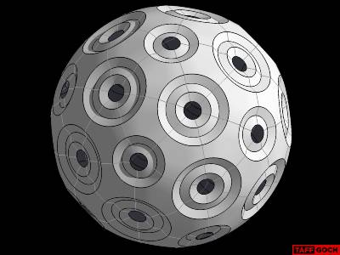
Taff: Papercraft sphere of buckyball/soccerball symmetry • This model can be constructed of paper, folded along curved lines • Paper cut-out patterns provided in model • The single pattern, of which 60 are required, scaled to fill a sheet of paper, will produce a large model • The pentagonal pattern, of which 12 are required, will produce a smaller model • Construction details, depicting how the 3D SketchUp model was produced, are included • Buckyball sphere was produced first, then the resultant module was "unfolded" in SketchUp, to create the paper pattern • (Tabs not yet added • I'll get right on that)

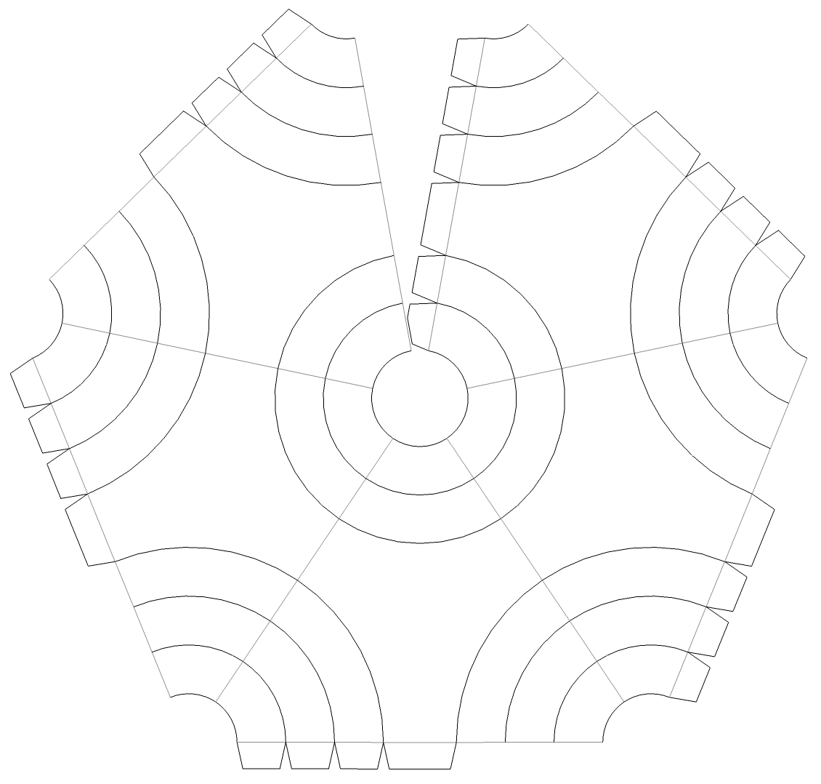
Dan: Taff,-- Please post pattern for "Buckyball Sphere - Curved Folds".

Taff: So, you discovered that posting, eh, Dan? I'm currently doing a paper test-construction, to double-check my work. I'm using a pent-ring pattern, to ensure that the papercraft won't be too big. You can peer-check the pattern, if you like....

Blair: Should be called “Fly-eye Sphere - Curved Folds”.

Taff: Blair, -- Considered it, but few people know the reference. More folks know "buckyball," particularly the younger generations. That's the audience, to which I'm directing most of my efforts. I figure, if you're our age, it's too late, already -- you're beyond reach (although, Dan appears to be an exception to the rule.)

578.1

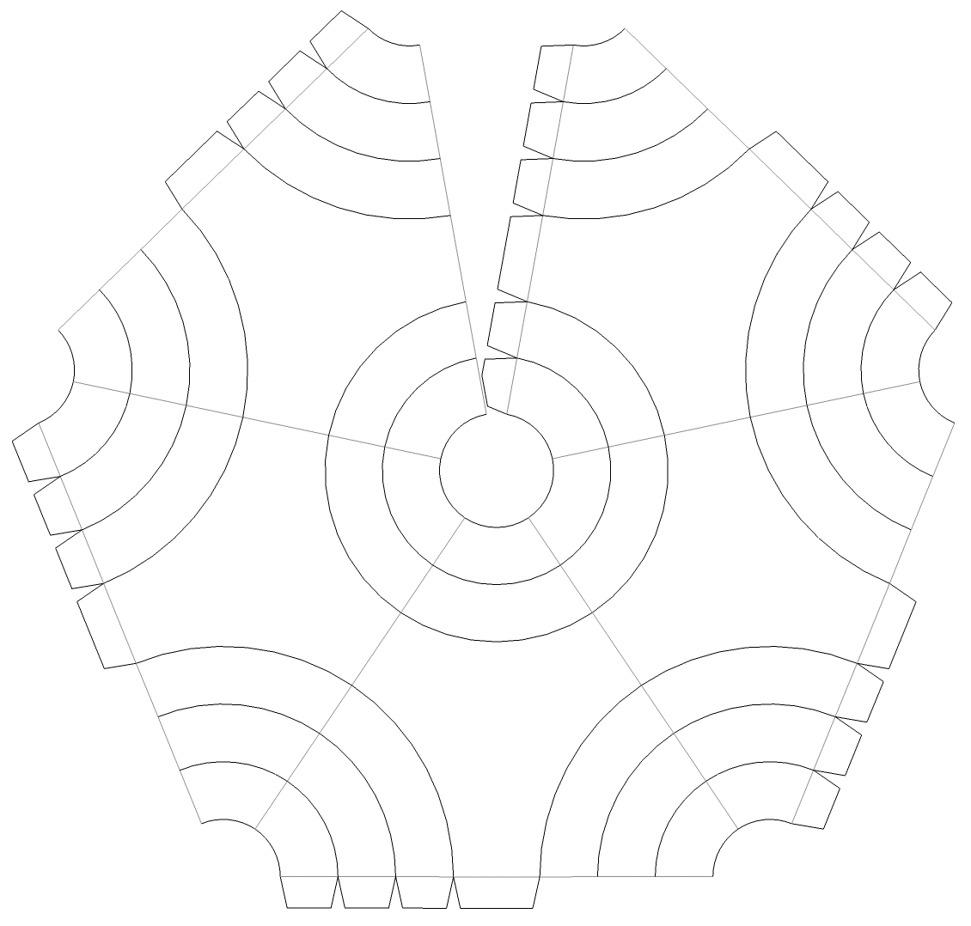

578.2
Dan: Taff, -- I have begun -- two pictures attached. I have put in double flaps, one above and one below at each joint - I don't mind at all that they show.

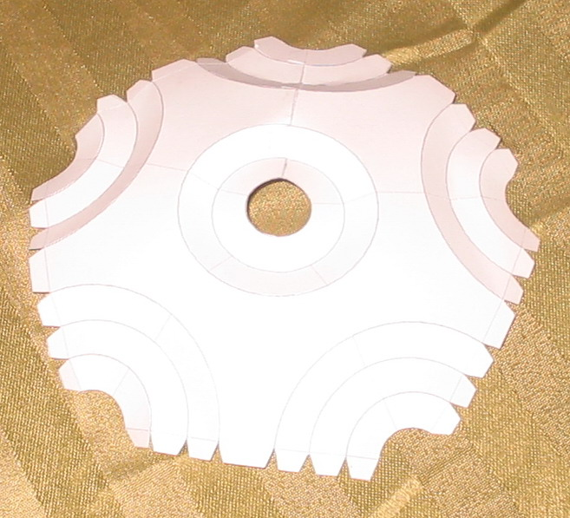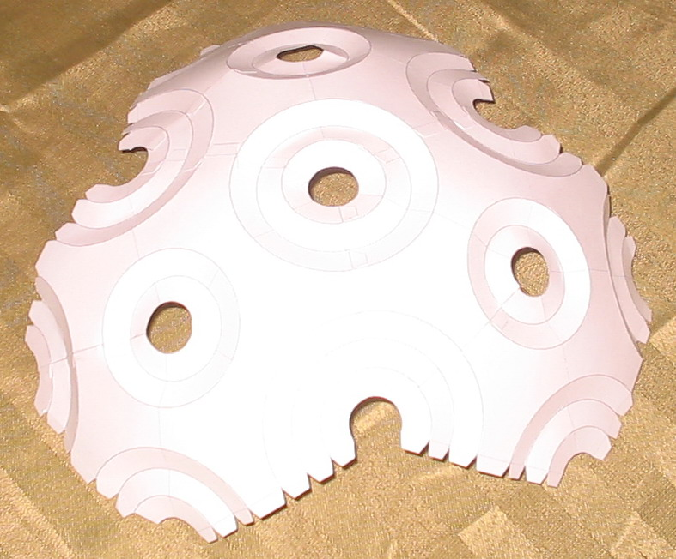

Taff: Card-stock looks to be working better than plain printer paper (my effort).

Dan: Taff, -- Yes card stock works very well with these curved folds, model retains strength very well. However, my printer doesn't like it very much; I have to help the paper feed though manually doing only one sheet at a time; sometimes I get blotches of ink.

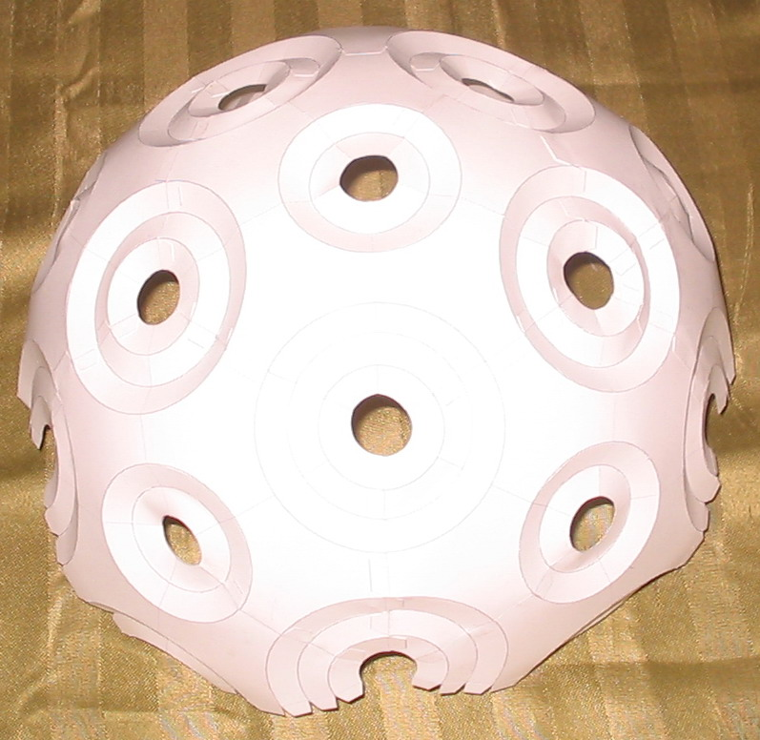 578.3
Dan: I managed getting it half done before retiring for the night.

Taff: Wow, the large circles "firmed up" nicely. I was concerned that the folds might be too shallow to provide rigidity. Looks like it's going to turn out all right, after all....

Dan: Model Completed - That was fun.

Taff: Nice! I'm relieved that the model pattern works (in reality). I definitely have to visit my hobby store for plastic stock, to make my own....

Larry: Dan, -- Can you make a how-to document so we can also give it a shot?

Dan: To Larry - It's just a matter of following the pattern - I would make little pencil dots to mark the sides of the flaps that get the glue. Tedious part was all that free-hand curved scoring. I suggest one try the "sherical dodecahedron " first which is easier.

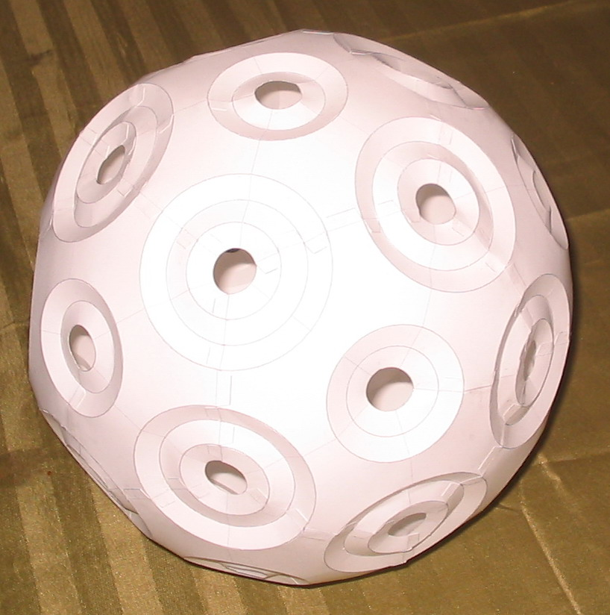

578.4

